Data Analysis Problem
Problem 1
Photometry and radial velocity data for the Cepheid type star HV2257 are given in Table 1-3, based on observations by Gieren (MNRAS vol 265, 1993) . The pulsation period of the star is $P=39.294 days$. A reference graph for the temperature – color relation and the bolometric correction tables are given in Figure 1 (Houdashelt et al., 2000) and Table 4 (http://xoomer.virgilio.it/hrtrace/Straizys.htm). Given that the solar luminosity is $L_{⨀}=3.96×{10}^{26}J s^{-1}$ and its bolometric magnitude $M_{⨀bol}=4.72$. Please do not use period-luminosity relation from the second question for this question.
- Plot the light curve based on Table 1, between phases 0.6 and 1.
- Plot the color in Table 2, between phases 0.6 and 1.
- Plot the Radial Velocity curve from Table 3, between phases 0.6 and 1.
- Calculate the average radial velocity of the star.
- Calculate the distance to this pulsating star using the observed data and supplementary data given in Table 4 and Figure 1. Assume that there is no extinction in this direction.
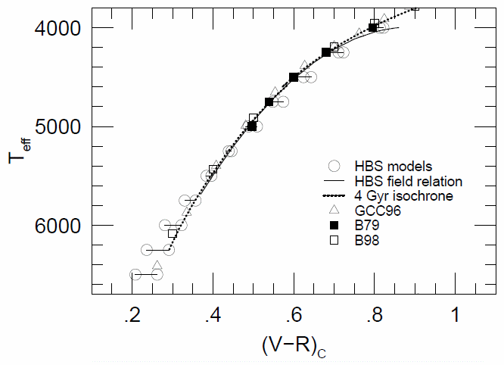
Fig. 1 The V-R color and temperature relation. Different symbols correspond to different authors.
Table 1 Table 2 Table 3
Phase | V mag |  | Phase | V – R |  | Phase | RadVel (km/s)
0.11 | 12.81 |  | 0.22 | 0.71 |  | 0.03 | 232
0.13 | 12.84 |  | 0.24 | 0.73 |  | 0.05 | 234
0.14 | 12.87 |  | 0.25 | 0.74 |  | 0.08 | 234
0.16 | 12.88 |  | 0.27 | 0.75 |  | 0.08 | 237
0.19 | 12.90 |  | 0.29 | 0.75 |  | 0.13 | 242
0.19 | 12.94 |  | 0.29 | 0.75 |  | 0.13 | 246
0.24 | 12.99 |  | 0.34 | 0.77 |  | 0.18 | 243
0.43 | 13.32 |  | 0.51 | 0.87 |  | 0.20 | 249
0.46 | 13.31 |  | 0.53 | 0.85 |  | 0.23 | 250
0.46 | 13.32 |  | 0.53 | 0.87 |  | 0.28 | 254
0.51 | 13.36 |  | 0.57 | 0.85 |  | 0.33 | 259
0.54 | 13.41 |  | 0.60 | 0.87 |  | 0.35 | 261
0.54 | 13.45 |  | 0.60 | 0.88 |  | 0.36 | 260
0.56 | 13.46 |  | 0.62 | 0.87 |  | 0.38 | 266
0.59 | 13.53 |  | 0.64 | 0.90 |  | 0.40 | 265
0.59 | 13.52 |  | 0.64 | 0.90 |  | 0.44 | 266
0.61 | 13.55 |  | 0.66 | 0.88 |  | 0.46 | 272
0.64 | 13.60 |  | 0.68 | 0.91 |  | 0.46 | 265
0.64 | 13.62 |  | 0.69 | 0.90 |  | 0.49 | 270
0.72 | 13.68 |  | 0.76 | 0.88 |  | 0.51 | 270
0.74 | 13.61 |  | 0.78 | 0.82 |  | 0.54 | 272
0.77 | 13.45 |  | 0.80 | 0.79 |  | 0.54 | 273
0.79 | 13.18 |  | 0.82 | 0.70 |  | 0.56 | 274
0.80 | 13.12 |  | 0.82 | 0.70 |  | 0.59 | 274
0.80 | 13.07 |  | 0.82 | 0.68 |  | 0.61 | 273
0.82 | 12.80 |  | 0.84 | 0.60 |  | 0.62 | 274
0.82 | 12.78 |  | 0.84 | 0.59 |  | 0.64 | 274
0.82 | 12.73 |  | 0.84 | 0.58 |  | 0.67 | 276
0.84 | 12.57 |  | 0.86 | 0.53 |  | 0.67 | 274
0.85 | 12.54 |  | 0.86 | 0.51 |  | 0.69 | 274
0.85 | 12.53 |  | 0.87 | 0.52 |  | 0.71 | 274
0.87 | 12.48 |  | 0.88 | 0.51 |  | 0.72 | 276
0.87 | 12.47 |  | 0.89 | 0.51 |  | 0.74 | 278
0.89 | 12.49 |  | 0.90 | 0.55 |  | 0.77 | 271
0.90 | 12.51 |  | 0.91 | 0.53 |  | 0.77 | 264
0.92 | 12.51 |  | 0.93 | 0.56 |  | 0.79 | 253
 |  |  |  |  |  | 0.80 | 259
 |  |  |  |  |  | 0.82 | 242
 |  |  |  |  |  | 0.85 | 230
 |  |  |  |  |  | 0.87 | 228
 |  |  |  |  |  | 0.90 | 224
 |  |  |  |  |  | 0.92 | 224
 |  |  |  |  |  | 0.92 | 225
 |  |  |  |  |  | 0.95 | 228
 |  |  |  |  |  | 0.96 | 228
Table 4. Bolometric correction
T_{eff}, K | BC, mag
9600 | -0.25
9400 | -0.16
9150 | -0.10
8900 | -0.03
8400 | 0.05
8000 | 0.09
7300 | 0.13
7100 | 0.11
6500 | 0.08
6150 | 0.03
5950 | 0.00
5800 | -0.05
5500 | -0.13
5250 | -0.22
5050 | -0.29
4950 | -0.35
4850 | -0.42
4700 | -0.57
4600 | -0.75
4400 | -1.17
3900 | -1.25
3750 | -1.40
3550 | -1.60
3400 | -2.00

Problem 2

BVRIJHKLMN photometry of 2 stars from the constellation Cassiopeia is given in Table 5. For both stars it is believed that their light is affected by extinction by diffuse Interstellar Medium (ISM) only. Assuming that the observation is done from outside the atmosphere.
- Using the data given in Tables 5 to 9, plot $E_{X-V}/E_{B-V}$ as a function of $1/λ_{X}$ for filters B, V, R, I, J, H, K, L, M, N for both stars. Fit approximate curves by eye (in particular, note that $E_{X-V}/E_{B-V}\sim const.$ as $1/λ_{X}→0$). X is each band in the photometric system.

$E_{B-V}$ is the colour excess.
- Using the graphs obtained in a), estimate $R_{V}$ and $R_{R}$ for each star.

$R_{V}=\frac{A_{V}}{E_{B-V}}$ and $R_{R}=\frac{A_{R}}{E_{R-I}}$

($A_{V}$ is the absorption in V).

Now apply these results in order to derive a distance estimate for IC 342, a spiral galaxy in Cassiopeia obscured by Milky Way. You should assume that the properties of the ISM in IC 342 are similar to those of the ISM in our Galaxy.
- Using the period-magnitude diagrams for 20 Cepheids from IC 342 (Figures 2 and 3) and assuming the period-luminosity relations:
$〈M_{R}〉=-2.91\left(\log\left(\frac{P}{day}\right)-1\right)-4.04$ and $〈M_{I}〉=-3.00\left(\log\left(\frac{P}{day}\right)-1\right)-4.06$
where $〈M_{R}〉$ and $〈M_{I}〉$ are the mean absolute magnitudes in filters R and I, find $A_{R}$ for objects in IC 342. Find the distance to IC 342.

Table 5 BVRIJHKLMN photometry of two stars in Cassiopeia
Star | MK class | $$\frac{B}{mag}$$ | $$\frac{V}{mag}$$ | $$\frac{R}{mag}$$ | $$\frac{I}{mag}$$ | $$\frac{J}{mag}$$ | $$\frac{H}{mag}$$ | $$\frac{K}{mag}$$ | $$\frac{L}{mag}$$ | $$\frac{M}{mag}$$ | $$\frac{N}{mag}$$
HD 4817 | K3Iab | 8.08 | 6.18 | 4.73 | 3.64 | 2.76 | 1.86 | 1.54 | 1.32 | 1.59 | -
HD 11092 | K4II | 8.66 | 6.57 | - | - | 3.10 | 2.14 | 1.63 | 1.41 | 1.65 | 1.44

Table 6 ${\left(B-V\right)}_{0}$ intrinsic colours for selected sp. types and luminosity classes
 | $$\frac{{\left(B-V\right)}_{0}}{mag}$$
 | II | Iab / Ia
F0 | - | 0.15
G0 | 0.73 | 0.82
K0 | 1.06 | 1.18
K3 | 1.40 | 1.42
K4 | 1.42 | 1.50

Table 7 Infrared intrinsic colours for selected sp. types of supergiant stars
 | $$\frac{{\left(V-R\right)}_{0}}{mag}$$ | $$\frac{{\left(V-I\right)}_{0}}{mag}$$ | $$\frac{{\left(V-J\right)}_{0}}{mag}$$ | $$\frac{{\left(V-H\right)}_{0}}{mag}$$ | $$\frac{{\left(V-K\right)}_{0}}{mag}$$ | $$\frac{{\left(V-L\right)}_{0}}{mag}$$ | $$\frac{{\left(V-M\right)}_{0}}{mag}$$ | $$\frac{{\left(V-N\right)}_{0}}{mag}$$
F0 | 0.20 | 0.31 | 0.36 | 0.51 | 0.60 | 0.64 | 0.65 | 0.82
G0 | 0.55 | 0.90 | 1.14 | 1.52 | 1.71 | 1.72 | 1.72 | 1.98
K0 | 0.95 | 1.59 | 2.01 | 2.64 | 2.80 | 2.87 | 2.79 | 3.14
K3 | 1.13 | 1.96 | 2.41 | 3.14 | 3.25 | 3.39 | 3.25 | 3.63
K4 | 1.20 | 2.13 | 2.59 | 3.37 | 3.44 | 3.62 | 3.46 | 3.84

 | $$\frac{{\left(V-R\right)}_{0}}{mag}$$ | $$\frac{{\left(V-I\right)}_{0}}{mag}$$ | $$\frac{{\left(V-J\right)}_{0}}{mag}$$ | $$\frac{{\left(V-H\right)}_{0}}{mag}$$ | $$\frac{{\left(V-K\right)}_{0}}{mag}$$ | $$\frac{{\left(V-L\right)}_{0}}{mag}$$ | $$\frac{{\left(V-M\right)}_{0}}{mag}$$ | $$\frac{{\left(V-N\right)}_{0}}{mag}$$
K0 | 0.60 | 1.03 | 1.23 | 1.72 | 1.94 | 1.97 | 1.90 | 1.92
K3 | 0.86 | 1.39 | 1.84 | 2.40 | 2.69 | 2.82 | 2.70 | 2.73
K4 | 0.96 | 1.61 | 2.16 | 2.77 | 3.05 | 3.22 | 3.08 | 3.02
Table 8 Infrared intrinsic colours for selected sp. types of giant stars
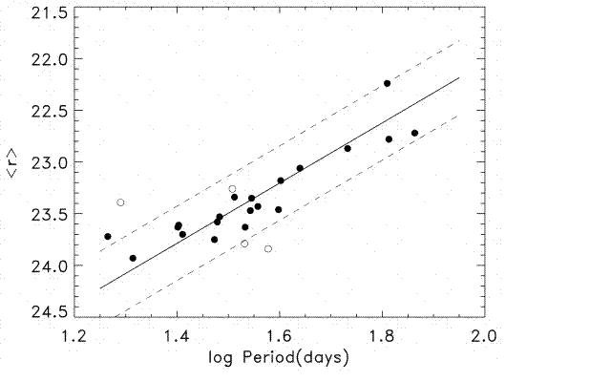

$$〈R〉$$

Fig. 2 $〈R〉$ is the mean apparent magnitude in filter R
Table 9 Effective wavelengths of selected photometric filters
Filter | B | V | R | I | J | H | K | L | M | N
$$λ_{F}/nm$$ | 450 | 555 | 670 | 870 | 1200 | 1620 | 2200 | 3500 | 5000 | 9000

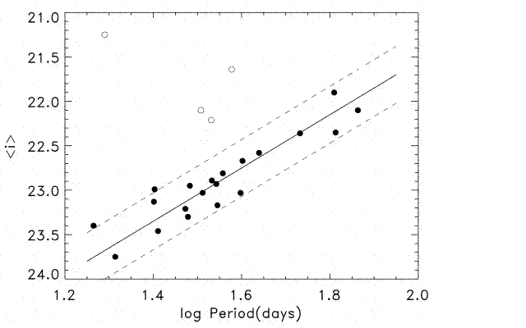
Fig. 3 $〈I〉$ is the mean apparent magnitude in filter I
$$〈I〉$$

